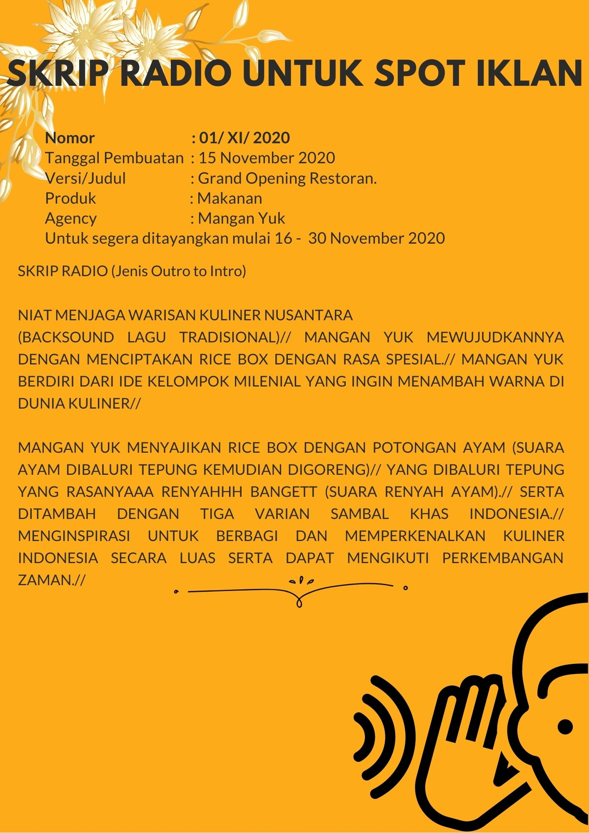

*Microsoft Office User*

*[Company Name] | [Company Address]*

*[Document Title]*

*[Document Subtitle]*

**LINK RECORD:**

<https://drive.google.com/file/d/1BF_mz7NhdLTz7WVNSYYIpGQa9vvitA0K/view?usp=sharing>

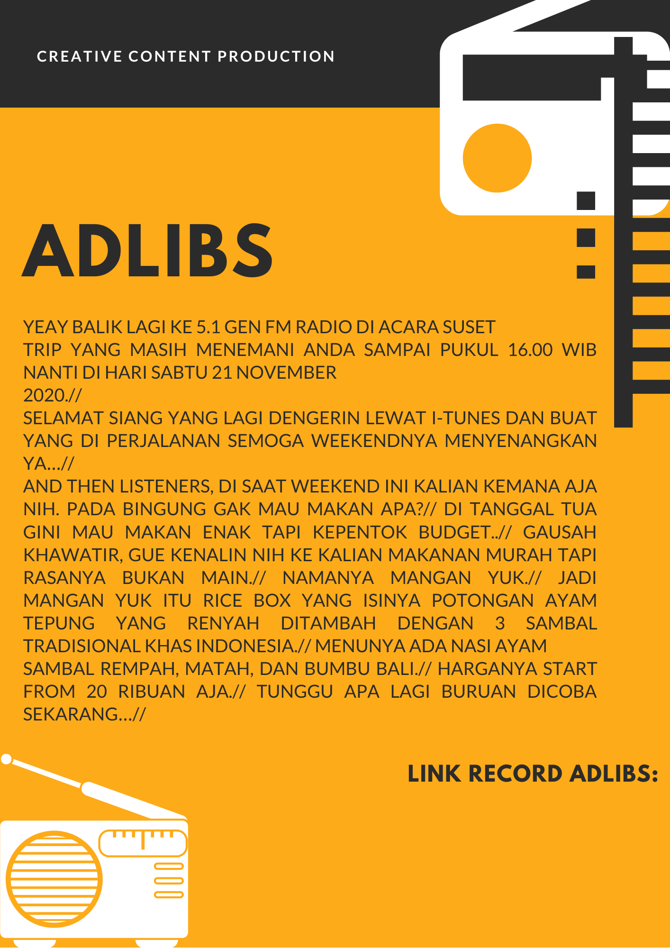ff

<https://drive.google.com/file/d/1_02tRp75YcfAYd7QwxdZRaH1Jyj4PDik/view?usp=sharing>